Mathematics and ADHD
Chancellor Liu Cochran
La Sierra University

Abstract
The purpose of this research paper is to better understand the relationship between mathematics and attention disorders such as ADHD, specifically in a high school mathematics classroom. Often, students with attention disorders perform at a much lower academic level than other students, but these same students have also shown that they can make a significant impact on the classroom and society. This research hopes to reveal why these students are not performing as well, highlight how they can contribute to classrooms and explore strategies that teachers can use that are useful in engaging these types of students.

Introduction
Over the years we have seen a rise in the diagnosis of ADHD (attention deficit hyperactivity disorder). From 1998-2009 the diagnosis of children with ADHD has risen from 6.9% of the population to 9%, according to the Center of Disease Control (2011). This may not seem like a huge percentage jump but to put it into perspective we have just fewer than 54 million children from ages 5-17 in America, according to the Department of Commerce (2010). This 2% increase from 6.9% to 9% is approximately 1,080,000 children, bringing the estimated total to around 5 million children from ages 5-17 in America, who have been diagnosed with ADHD. One study by the Appalachia Educational Laboratory even found that 33% of ADHD students drop out of school (1997). Which means that almost 2 million students with ADHD are dropping out of High School, which is an alarming number. Many people argue that we are over diagnosing ADHD in today’s society, but I think those people are missing the point. We shouldn’t care whether or not the child has diagnosed ADHD, let the doctors worry about that, we should just be focusing on how to teach these special minds, diagnosed or not. If the student has attention problems they should still be able to thrive in a school environment and if we as teachers have a system to teach these students then it shouldn’t matter the quantity. Obviously, these numbers are frightening; we are not catering to the special needs of these children. We are letting millions of minds slip through the cracks of our education system and it is hurting our country. Continuing down this path is simply not an option. So what can we do about it?

Definition and Characteristics
In order to find strategies and develop educational plans for ADHD students we first need to fully understand what exactly ADHD is, where it spawns from, and characteristics that come with it. According to the American Speech-Language-Hearing Association (2014), “ADHD is a condition of the brain that affects a person's ability to pay attention. It is most common in school-age children.” Also according to the DSM IV
(2000), there are three subtypes of ADHD. Each of these subtypes is categorized by specific characteristics found in people with ADHD. The three subtypes are Inattentive, Hyperactive-Impulsive, and the Combined type; which is a mixture of the two.
1. Predominantly Inattentive Type
Sagvolden et. al. (2000), state that, the predominantly inattentive type is “Characterized by symptoms of inattentiveness, such as distractibility, failure to complete work, forgetfulness, and disorganization, the IN (inattentive type) subtype differs from the more commonly recognized combined (CB) subtype of ADHD in that symptoms of hyperactivity and impulsivity are absent or minimal.”
2. Predominantly Hyperactive-Impulsive Type
This subtype of ADHD is characterized by hyperactivity and impulsivity, which in turn leads to inattentiveness. The difference here between this subtype and the inattentive subtype is that this subtype struggles to hold still, stay quiet, remembering…etc., whereas according to the NRCADHD in the inattentive subtype, (2004)“…some children [have] severe problems in paying attention, but little or no problem with hyperactivity at all” (p. 2).

3. Combined Type
This type is obviously a mixture between the two subtypes of ADHD. This subtype is characterized as a combination of both inattentiveness and hyperactivity.
Contributions
Now that we are aware of what ADHD is and the characteristics of the different types of ADHD, we can go into how ADHD students contribute to the classroom and more so into society. We know the negative aspects of ADHD in the classroom. The kid who can’t sit still, or stay quiet, the student who the teacher is constantly yelling at or asking to concentrate. These are classic examples of how ADHD students interact in the classroom, but there can and should be a positive to having ADHD students in your class. ADHD students have many traits just like other kids that can contribute to a positive classroom and benefit not just the ADHD students but also the kids around them. These ADHD attributes should be known to all teachers so they are aware and prepared for utilizing a student with ADHD in their very own classroom.
- Energetic
One positive attribute that ADHD students bring to the classroom is energy. This energy is sometimes viewed as a disadvantage to the classroom because it can be distracting and can cause the student to be inattentive. These student’s energy can be channeled into daily tasks and may translate into society through a job that requires movement, talking, and energy.

- Creativity
Again this trait may sometimes be taken as a negative characteristic in the classroom because the student cannot stay on task. They are constantly going through ideas in their head that race through their mind and sometimes out of their mouths. These ideas are constantly coming in and may bring a creative solution to a problem with them. This attribute is one that can be very useful in the classroom
- Sensitivity
Some ADHD individuals are very sensitive and tend to feel things on a deeper level than others. Sometimes this translates into physical and emotional instability but cultured correctly this trait can greatly contribute to a classroom, because these same students are highly capable of compassion, caring, introspection and empathy, which is important in the classroom and more so in group work.
- Intuition
Since these students tend to be distracted by other things this means that they are focusing on other things that we may not be focusing on. This leads to ADHD students having a higher capacity for being aware of their surroundings and allows a wider scope of their environment.
- Flexibility
ADHD students have the unique ability to be moving, and offer much energy to the classroom. Since these students tend to be distracted they are used to constantly changing they may have a “go with the flow” kind of mentality. This is good for the classroom because it can be used to encourage others to try something new. Obviously this isn’t true for every person so the teacher must be aware of whether the student will adapt to change well.
- Enthusiasm
This may be the most important attribute that ADHD students can bring to the classroom. Enthusiasm is a strong tool because it inspires motivation and energy for not just the student but also for the people around that student. This enthusiasm can encourage them to try new things, find an innovative solution, overcome fear or motivate others into participation.
There are many traits and characteristics of ADHD students that allow them to greatly contribute to the classroom. Obviously, these characteristics don’t apply to all ADHD students but this provides a general idea of the different characteristics that teachers can look for in their ADHD students. So, now the question becomes, how do I take these characteristics and apply them to my classroom? What strategies should I use for my ADHD students?
Useful Classroom Strategies for ADHD Students
In order ensure that ADHD students can contribute in the regular classroom initial and specialized strategies should be in place. Teachers should have an overall strategy for ADHD students that determine general practices that should be used everyday. Along with these general strategies teachers should have special content area strategies that coincide with the needs of the ADHD student.

General Strategies
Evaluate the child’s individual needs and strengths
The teacher should have a technique in place in order to evaluate the needs and strengths of the ADHD student. This will include general observation and assessment, working with parents and other diagnostic individuals in order to determine not only academic needs but also behavioral needs. This determining of strengths and needs will allow the teacher to better accommodate the students and place them in areas where they will succeed.
Select Appropriate Instructional Strategies
After the needs and strengths are properly assessed, the teacher will then select appropriate instructional activities to use for individual students. According to Teaching Children with ADHD (2008), teachers need to, “determine which instructional practices will meet the academic and behavioral needs identified for the child. Select practices that fit the content, are age appropriate, and gain the attention of the child” (p. 4).
Integrate Appropriate Practices
Students who receive special education services need their content integrated into appropriate practice methods such as IEPS (Individual Education Practices). Teachers should consult parents, students and other educators in order to determine how the IEP should be created and implemented. The IEP should be created to (2008), “ reflect annual goals and the special education related services, along with supplementary aids and services necessary for attaining those goals”(p. 4).

Introducing Lessons
There are many different strategies that can be applied when introducing a lesson to ADHD students. This is an important because students with ADHD learn best with structured curriculum. In order to be an effective teacher, teachers should learn how to preview what is expected of their students. This can be done by providing organizers, providing reviews, setting learning and behavioral expectations, simplifying instructions and scheduling lessons. This will help keep ADHD students on task.
Conducting Lessons
When it comes to conducting lessons with ADHD students, teachers need to be constantly monitoring, examining answers, analyzing comprehension and most of all assessing whether additional help is needed. Teachers can be effecting at conducting lessons by being predictable with lessons, emphasizing participation, using visual aids, watching noise level, highlighting key points, using cooperative learning and using effective technology. There are many other techniques that can be implemented in order to accentuate conducting a lesson to ADHD students in a regular classroom but these points highlight some key ideas that are essential to ADHD students.
Concluding Lessons
When concluding lessons with ADHD students it is important to maintain the structure that we have stressed. Teachers can do this by providing warnings for when lessons are concluding, checking assignments done by the students, and previewing the lesson to come. This highlights general strategies that we can use in our classroom, but what about specific content area classrooms, such as math?

Specific Strategies for Math Classroom
For the mathematics classroom particular strategies need to be implemented because of the evidence that surrounds mathematics and ADHD. Miriam Cherkes-Julkowski (2014) states that the problem “is not carelessness but a lack of sufficient attention resources.” Mathematics requires sustained attention, working memory and self-monitoring, many of which are attributes that ADHD students struggle with in fact, as these students move onto higher level of mathematics the further they fall behind. Teachers can help these ADHD students through a variety of strategies.
Useful Strategies
- Partnering
  - Provides a social environment for individuals including the ADHD students, offers accountability
- Use real life examples
  - Using money or other real world applications may help focus student
- Board and Computer math games
  - Use to retain information and attention of ADHD students
- Highlighting key words
  - Teaching key words can help focus students and give them a basis for word problems
- Experimenting
  - Visualizing word problems may help ADHD students imagine and focus attention especially with word problems
- Knowing the student’s Multiple Intelligence
  - Knowing how the student learns can focus their attention
  - Chart below can be used to correlate MI and ADHD, from Thinking Positively (2006).

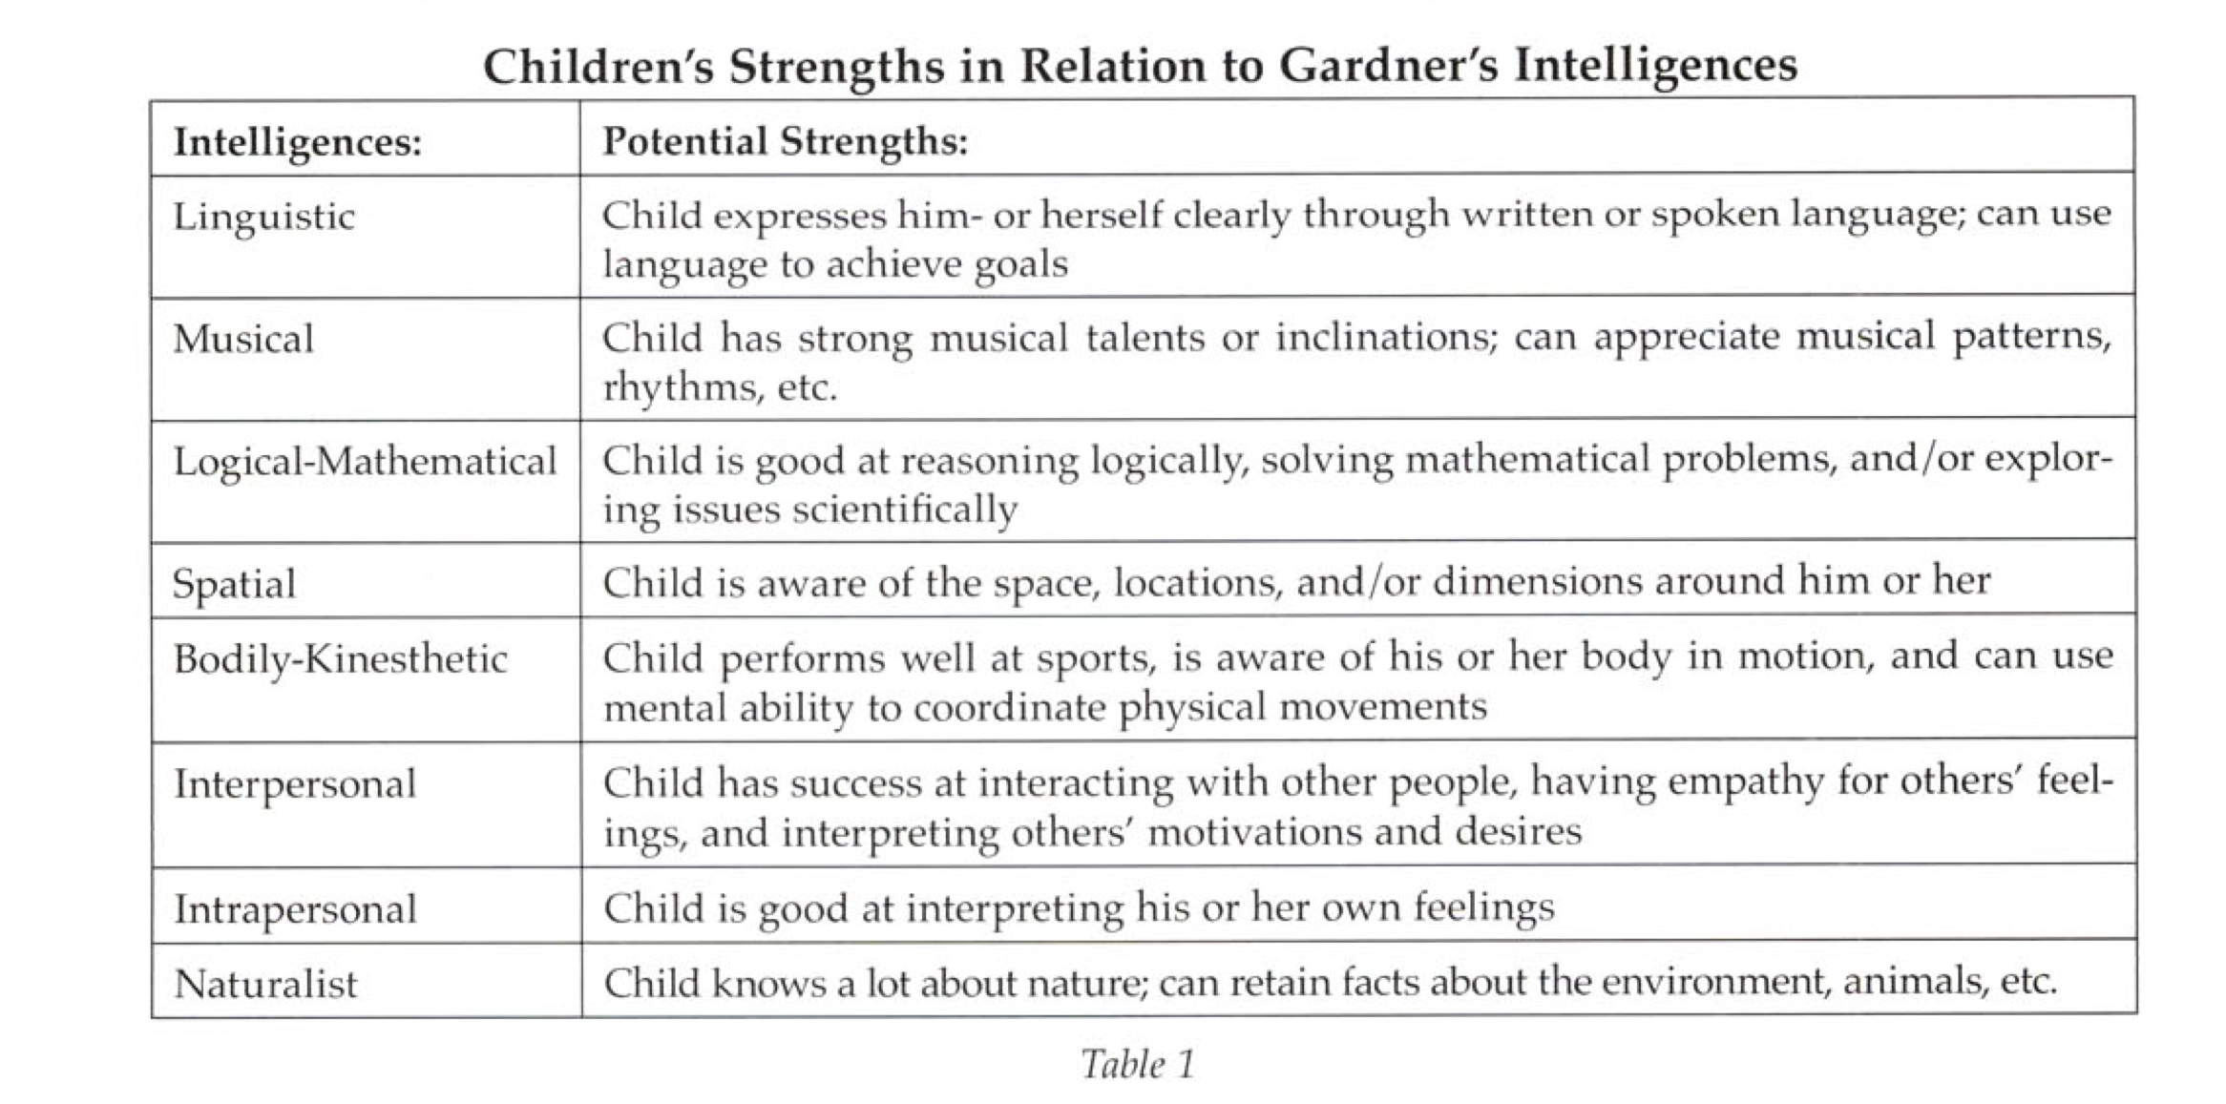
All of these strategies are a great start to better educating individuals with ADHD in the mathematics classroom.

Conclusion
It is popular belief that many powerful minds in our history had traits of ADHD. People such as, Thomas Edison, Leonardo da Vinci and Albert Einstein. People with ADHD have contributed to society in ways that have been transformational to our modern world. So, why has it taken us so long to tap into this “disorder” to transform our classrooms? As teachers it is our responsibility to place a new emphasis on fully educating this population of students with attention deficiencies. We as a country cannot afford to continue down his road of wasting millions of minds in our education system. We have the resources, knowledge and capacity to entirely teach these individuals. After all one, of those minds could turn out to be the next Edison, da Vinci or Einstein.

References
ADHD and dropout rates. (n.d.). Play Attention RSS. Retrieved June 11, 2014, from http://www.playattention.com/adhd-and-dropout-rates/
ADHD: Building Academic Success. (n.d.).LD OnLine: The world's leading website on learning disabilities and ADHD. Retrieved June 11, 2014, from http://www.ldonline.org/article/5925/
Age and Sex Composition. (n.d.). Census Briefs. Retrieved June 10, 2014, from http://www.census.gov/prod/cen2010/briefs/c2010br-03.pdf
Attention Deficit/Hyperactivity Disorder (ADHD). (n.d.). Attention Deficit/Hyperactivity Disorder (ADHD). Retrieved June 11, 2014, from http://www.asha.org/public/speech/disorde
Center, A. r. (2004). AD/HD Predominantly Inattentive Type. chadd,1. Retrieved June 10, 2014, from http://www.help4adhd.org/documents/wwk8
Diagnostic and statistical manual of mental disorders: DSM-IV-TR. (4th ed.). (2000).Washington, DC: American Psychiatric Association.
Famous People With ADHD Traits. (n.d.).Attention Deficit ADD ADHD. Retrieved June 12, 2014, from http://www.attentiondeficit-add-adhd.com/famous-people-with-adhd.htm
Harrison, J. R., Bunford, N., Evans, S. W., & Owens, J. S. (2013). Educational Accommodations for Students With Behavioral Challenges: A Systematic Review of the Literature. Review of Educational Research, 83(4), 551-597.
Health Guides: Help for Adult ADHD. (n.d.). ADHD Benefits. Retrieved June 12, 2014, from http://www.sharecare.com/health/add-adhd/health-guide/managing-adult-adhd/using-the-benefits-of-adhd-to-your-advantage-3
Karoll, D. (2008). Why is Math So Hard for Some Children? The Nature and Origins of Mathematical Learning Difficulties and Disabilities. Journal of Developmental & Behavioral Pediatrics,29(3), 241.
Math & ADHD: Carelessness or Accidental Error?. (n.d.). Smart Kids With LD RSS. Retrieved June 12, 2014, from http://www.smartkidswithld.org/school-wise/math-adhd-carelessness-or-accidental-error
NCHS Data Brief. (2011, August 18).Centers for Disease Control and Prevention. Retrieved June 11, 2014, from http://www.cdc.gov/nchs/data/databriefs/db
Neihart, M. (2003). Gifted Children with Attention Deficit Hyperactivity Disorder (ADHD). . ERIC Digest, 10(0), 4. Retrieved June 11, 2014, from the Educational Resource Information Center database.
Reid, R., & Johnson, J. (2011). Teacher's Guide to ADHD. What Works for Special-Needs Learners Series. New York: Guilford Press.
Sagvolden, T., Dasbanerjee, T., Zhang-James, Y., Middleton, F., & Faraone, S. (2008). Behavioral and genetic evidence for a novel animal model of Attention-Deficit/Hyperactivity Disorder Predominantly Inattentive Subtype.Behavioral and Brain Functions, 4(1), 56.
Sherman, J., Rasmussen, C., & Baydala, L. (2006). Thinking Positively: How Some Characteristics of ADHD Can Be Adaptive and Accepted in the Classroom. Childhood Education, 82(4), 196-200.
Teaching children with attention deficit hyperactivity disorder: instructional strategies and practices. (2008). Washington, D.C.: U.S. Department of Education.
Wilkinson, S., Harvey, W. J., Bloom, G. A., Joober, R., & Grizenko, N. (2013). Student teacher experiences in a service learning project for children with attention-deficit hyperactivity disorder. Physical Education & Sport Pedagogy,18(5), 475-491.
Zwi, M., & York, A. (2004). Attention-deficit hyperactivity disorder in adults: validity unknown1. Journal of advancements in psychiatric treatment, 10, 248-256. Retrieved June 10, 2014, from http://apt.rcpsych.org/content/10/4/248.fu

